**CS-470 5-3 Using the Database**

Barbara McKenney

CS-470 Full Stack Development II (2025)

Professor: Ogoh

08/03/2025

* **QuestionWithoutFilter Test Results**

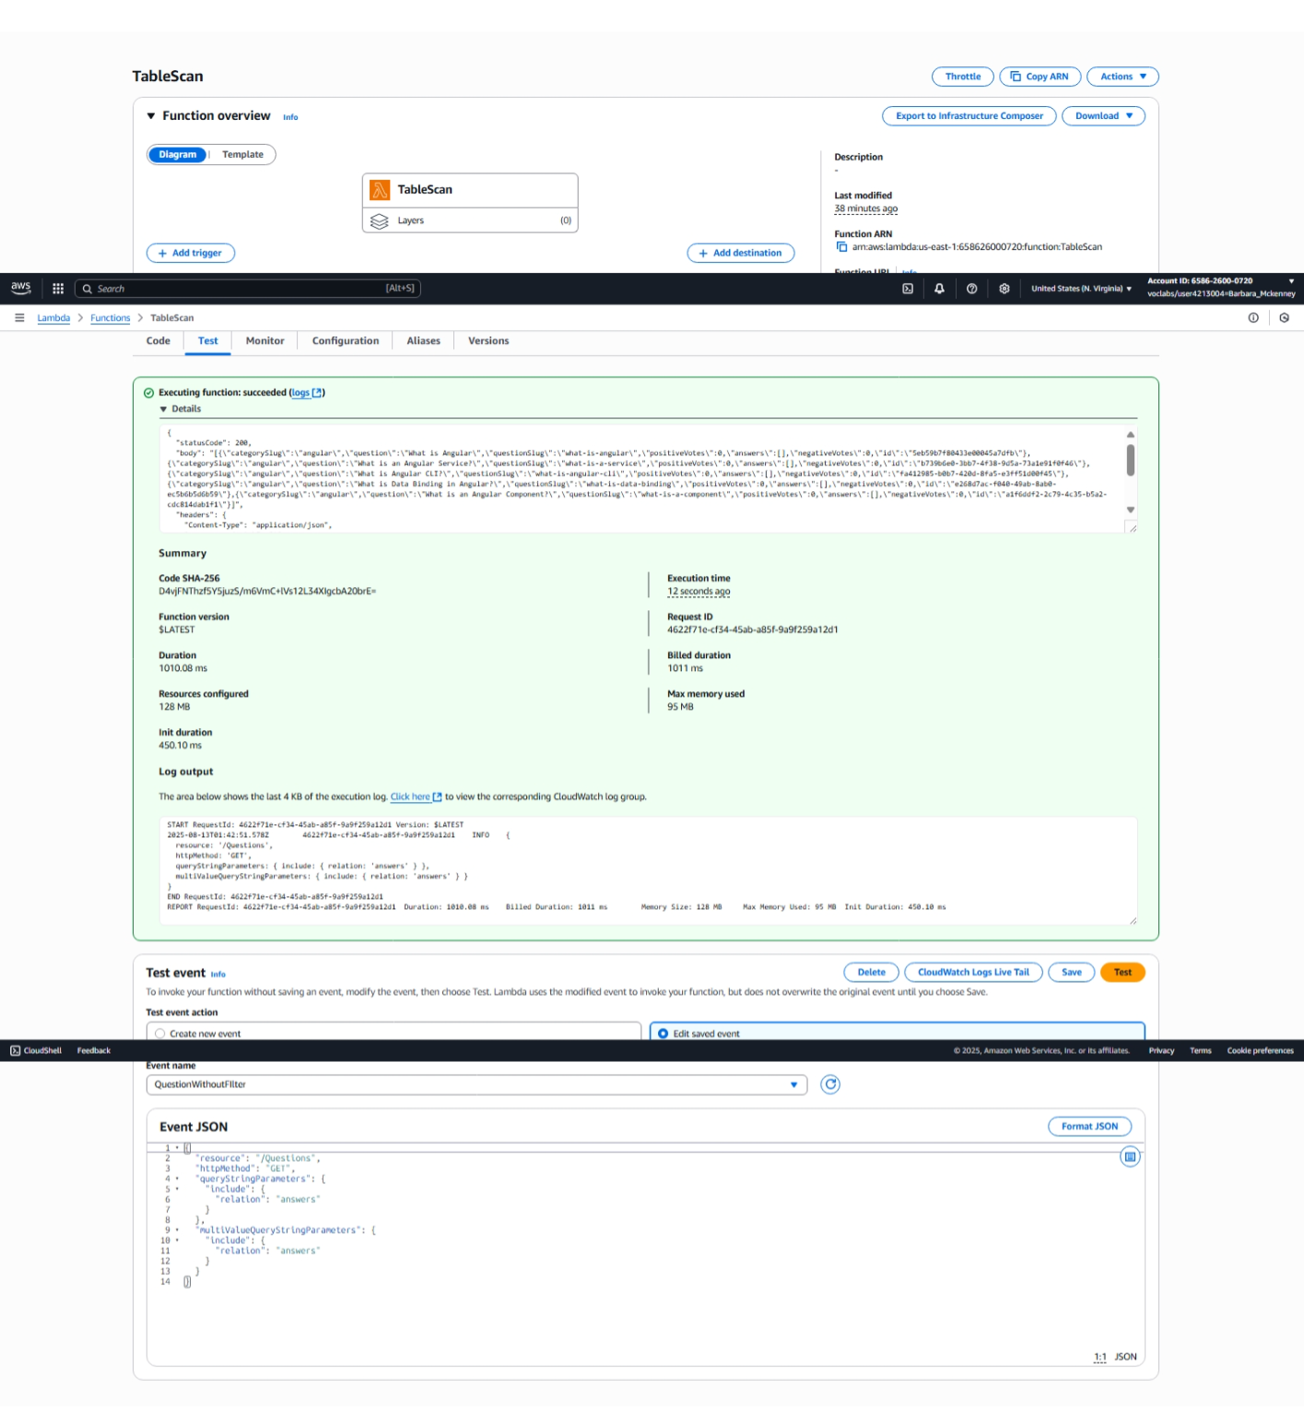

* **QuestionWithFilter Test Results**

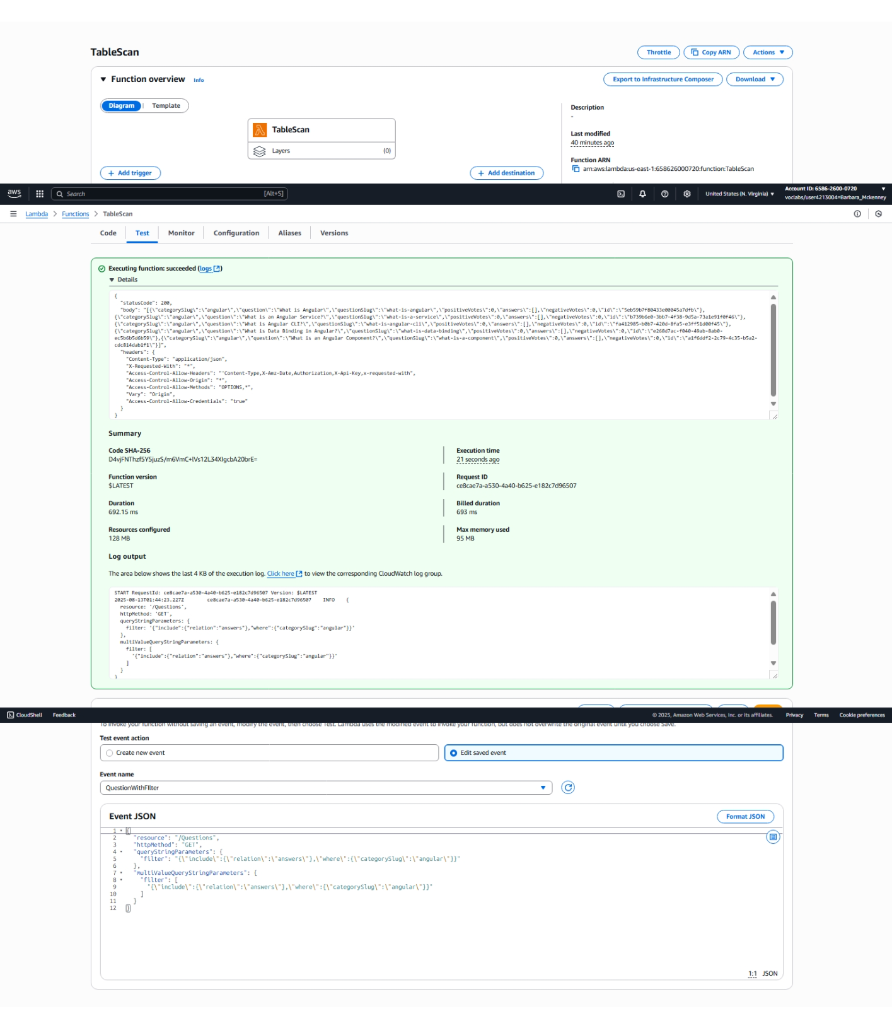

* **AnswerWithOutFilter Test Results**

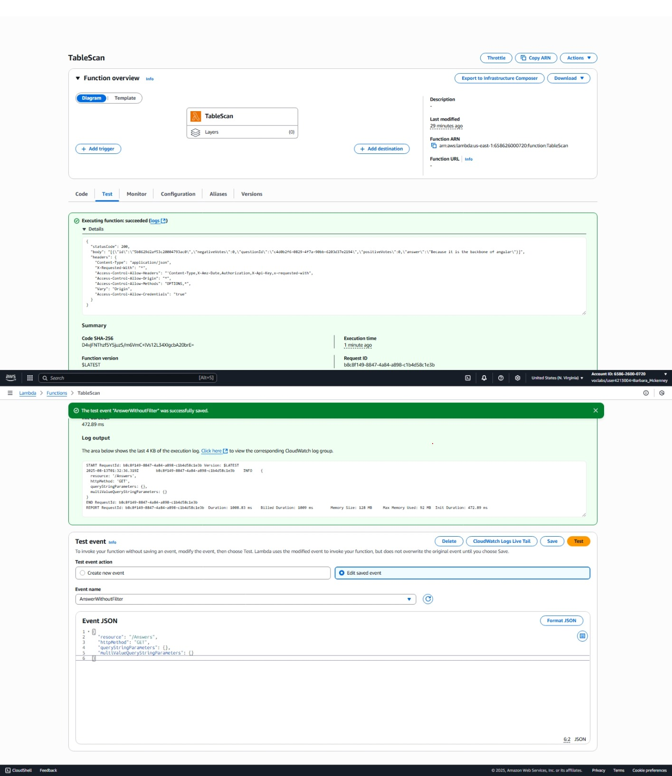

**Part II: Single-Record Fetch**

* **TestGetQuestion Results**
* **Get**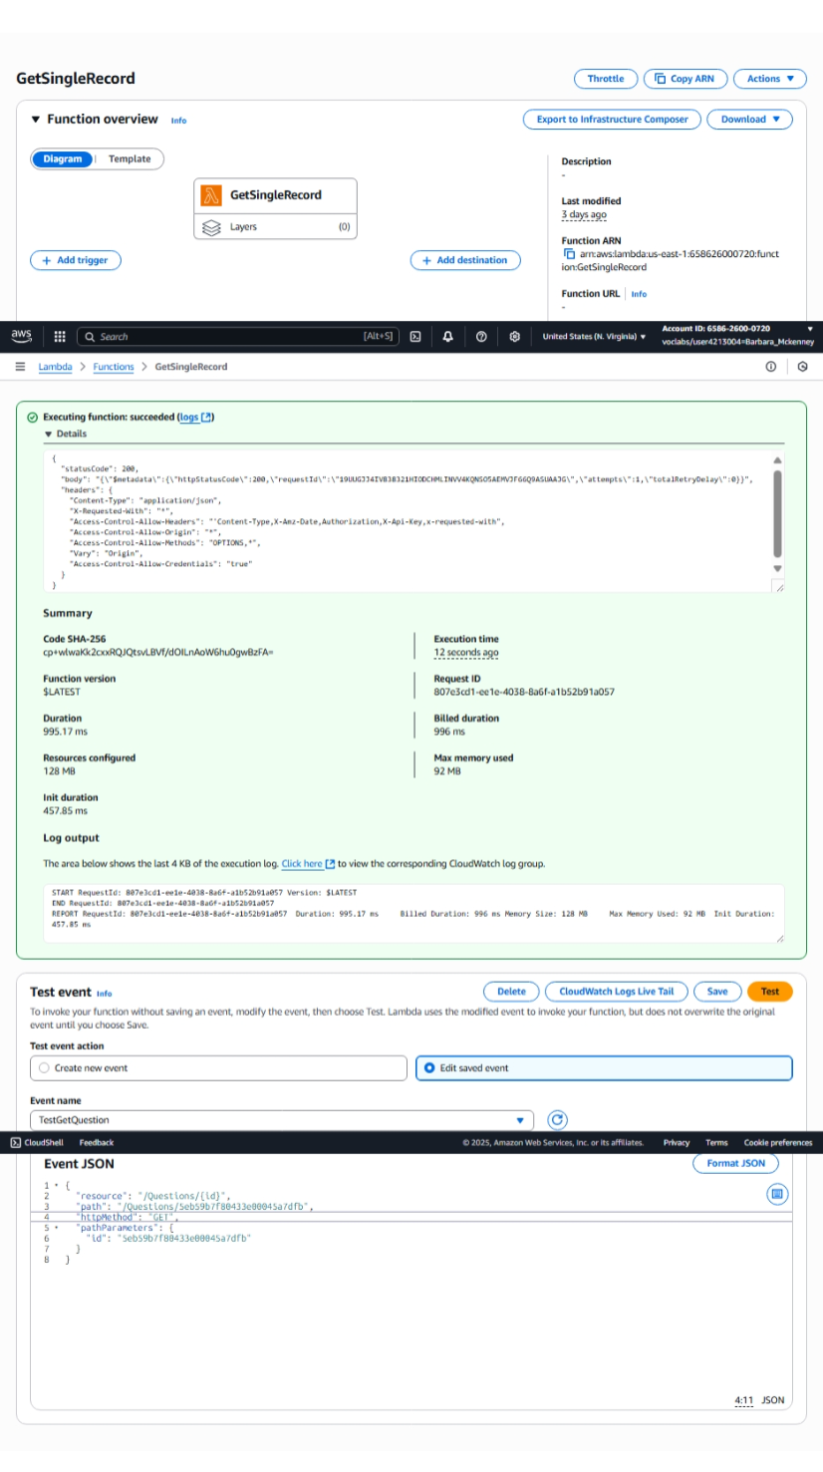
* **TestGetAnswer Results**

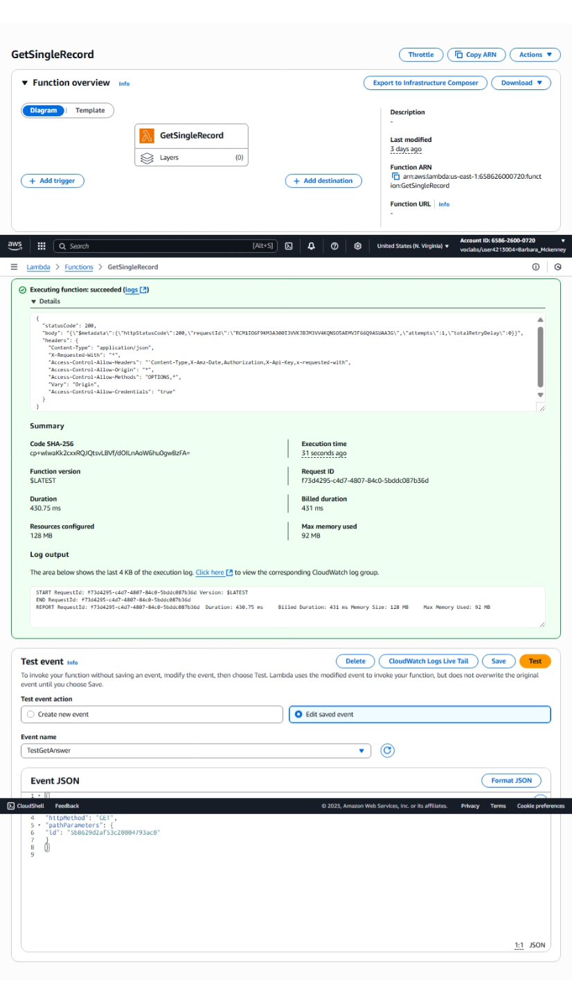

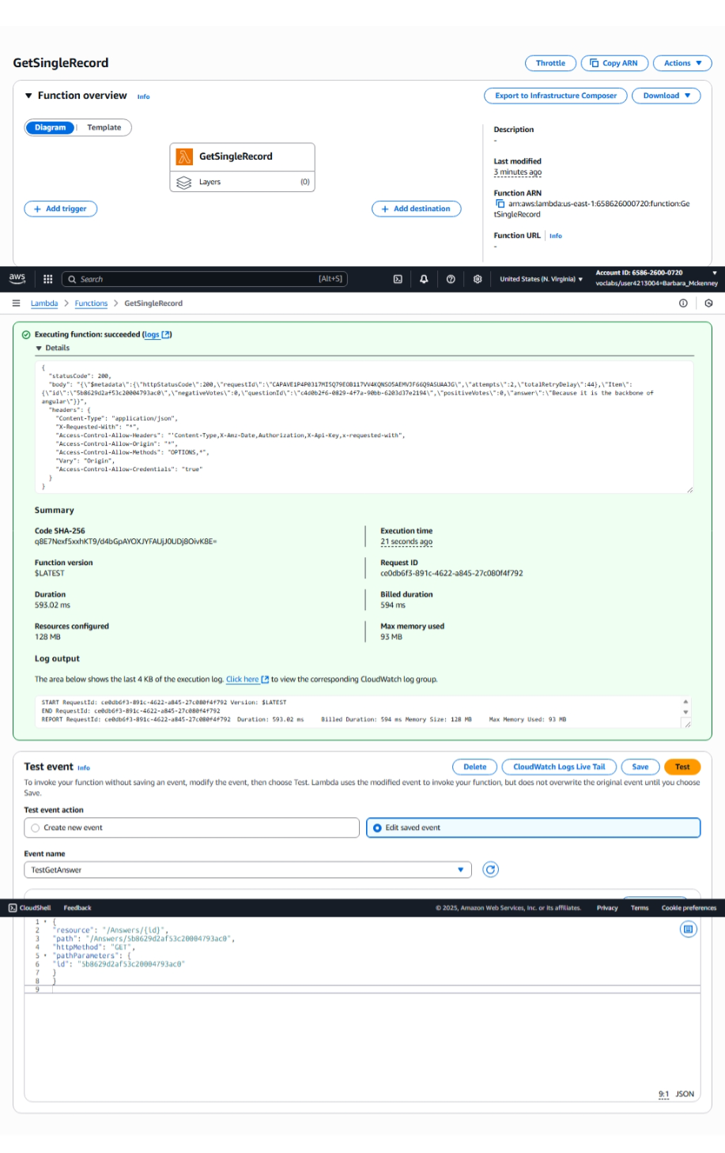

**Part Three: Upserting Records**

* **TestPost Results**

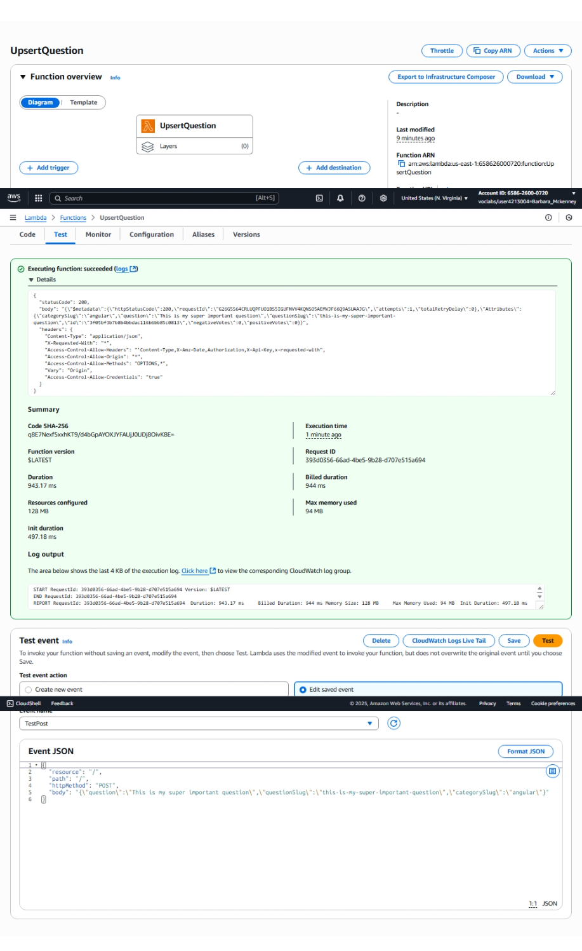



UpsertAnswer TestPost Results

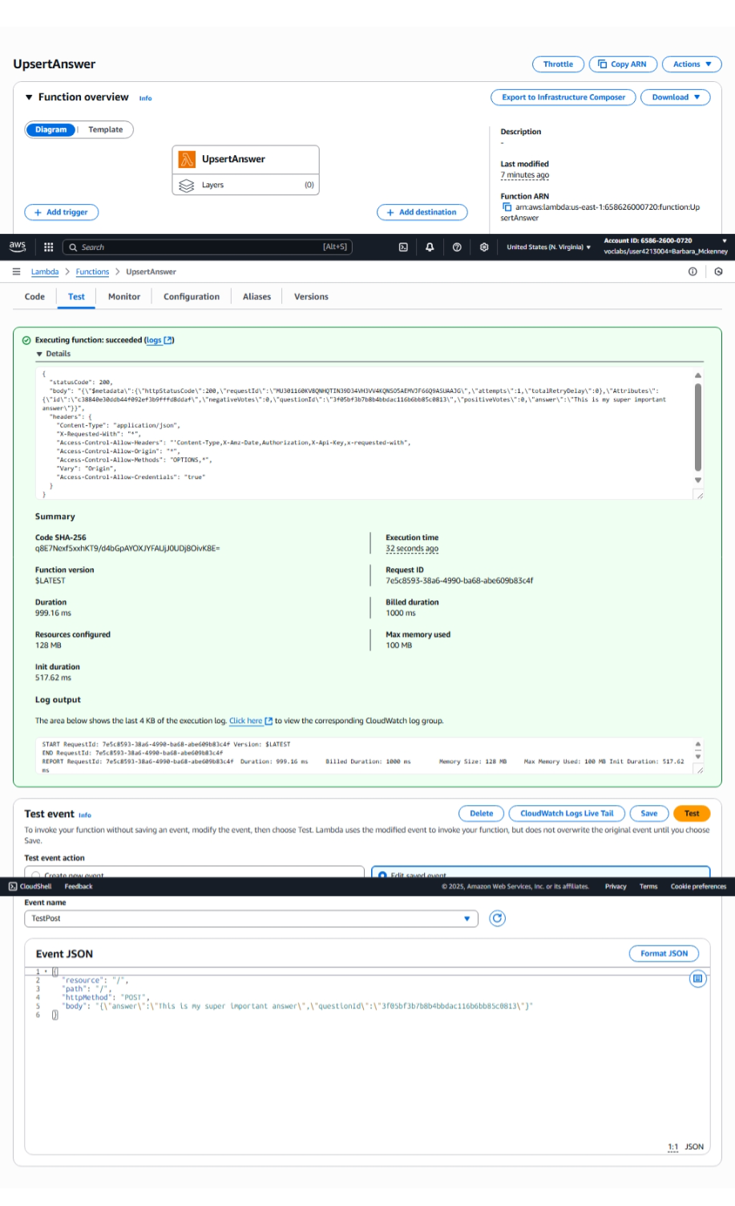

Part Four: Deleting Records

TestDeleteQuestion Results

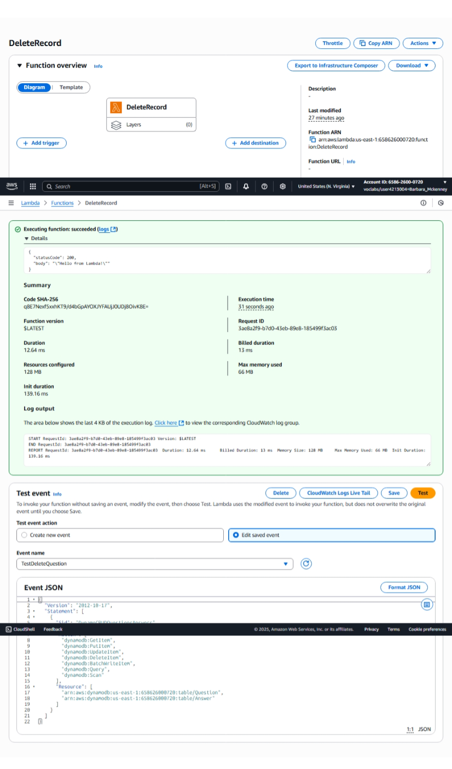

TestDeleteAnswer Results

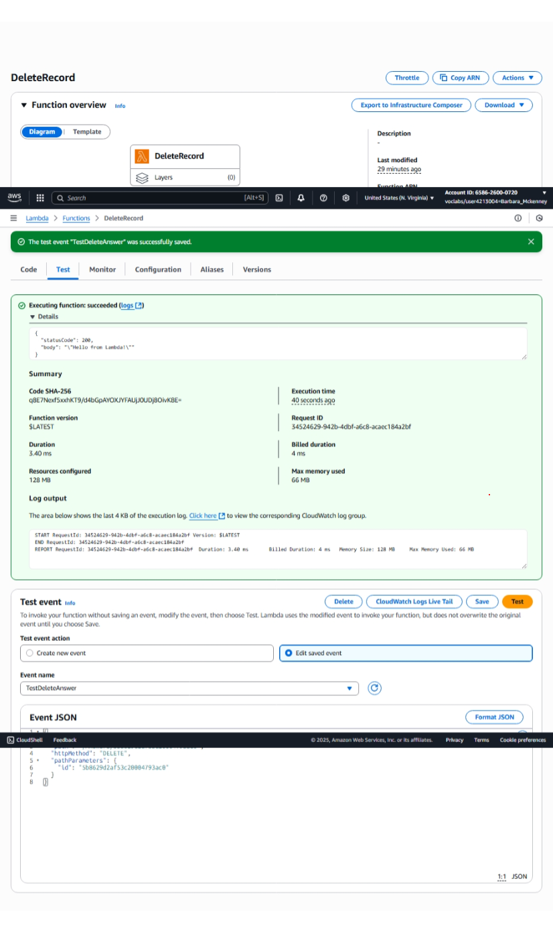

TestDeleteQuestion Results

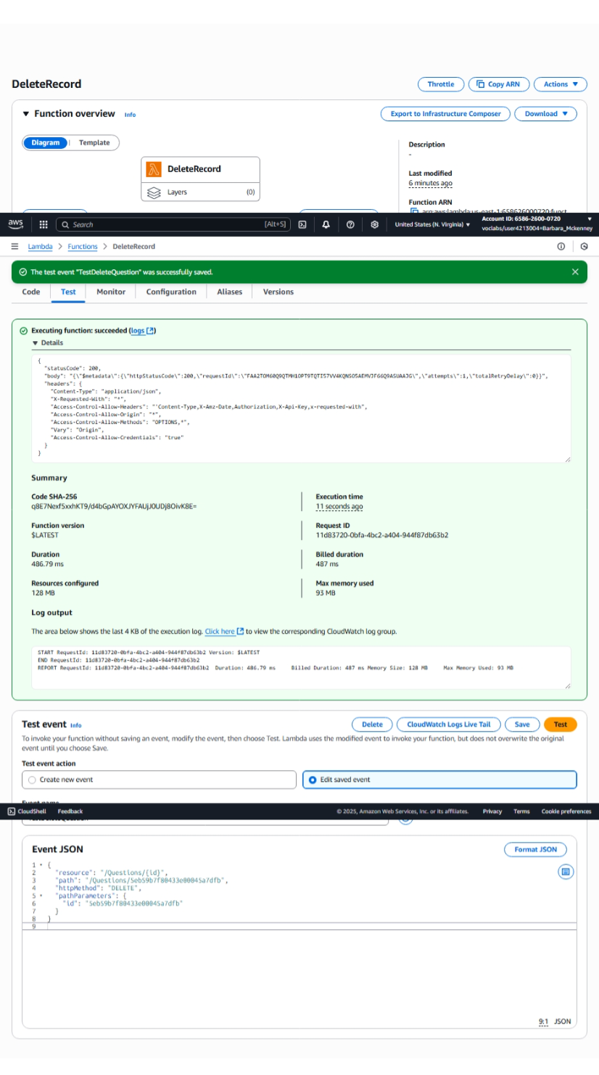

TestDeleteAnswer Results

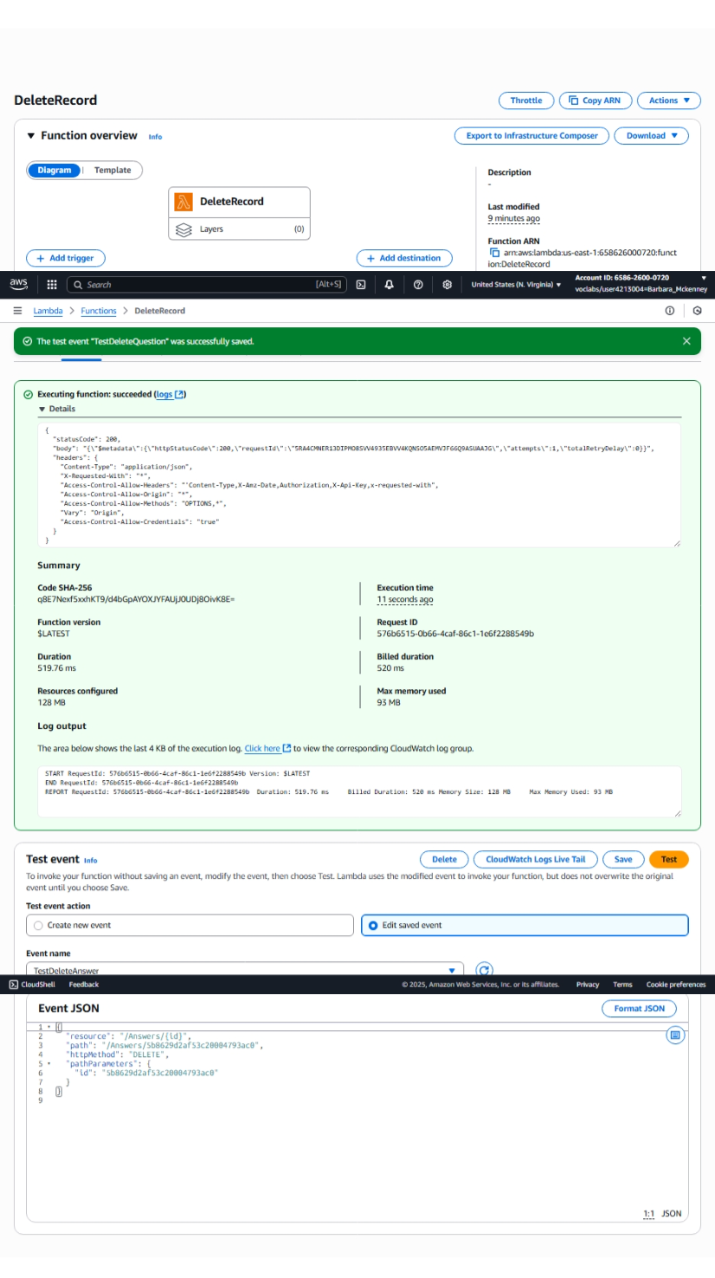

UpsertQuestion code + directory tree

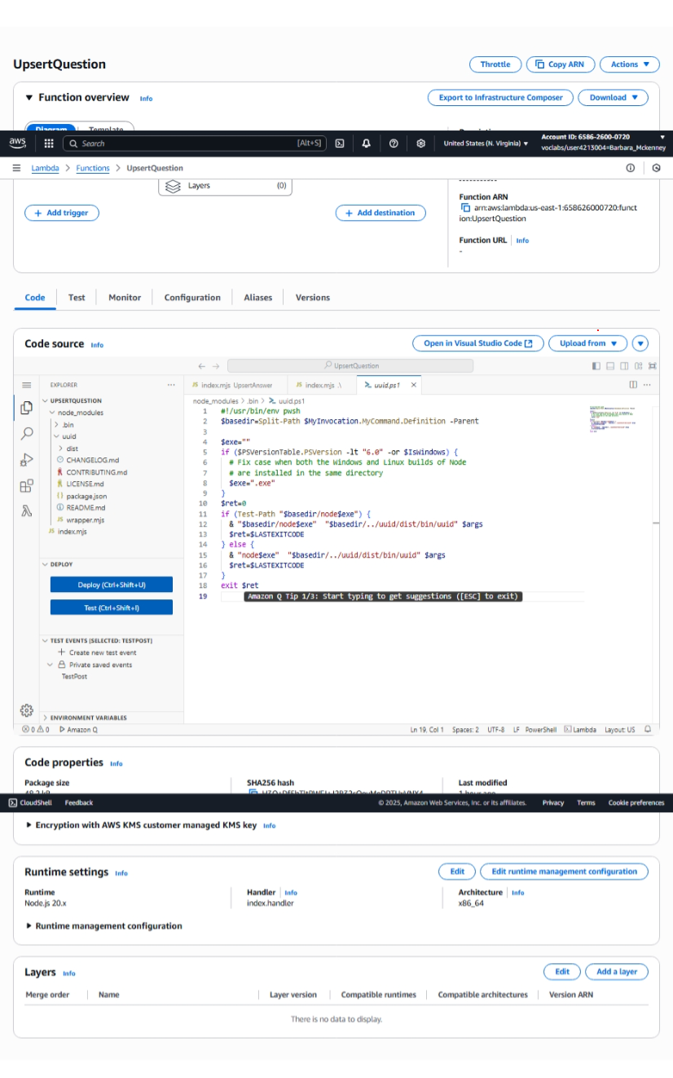

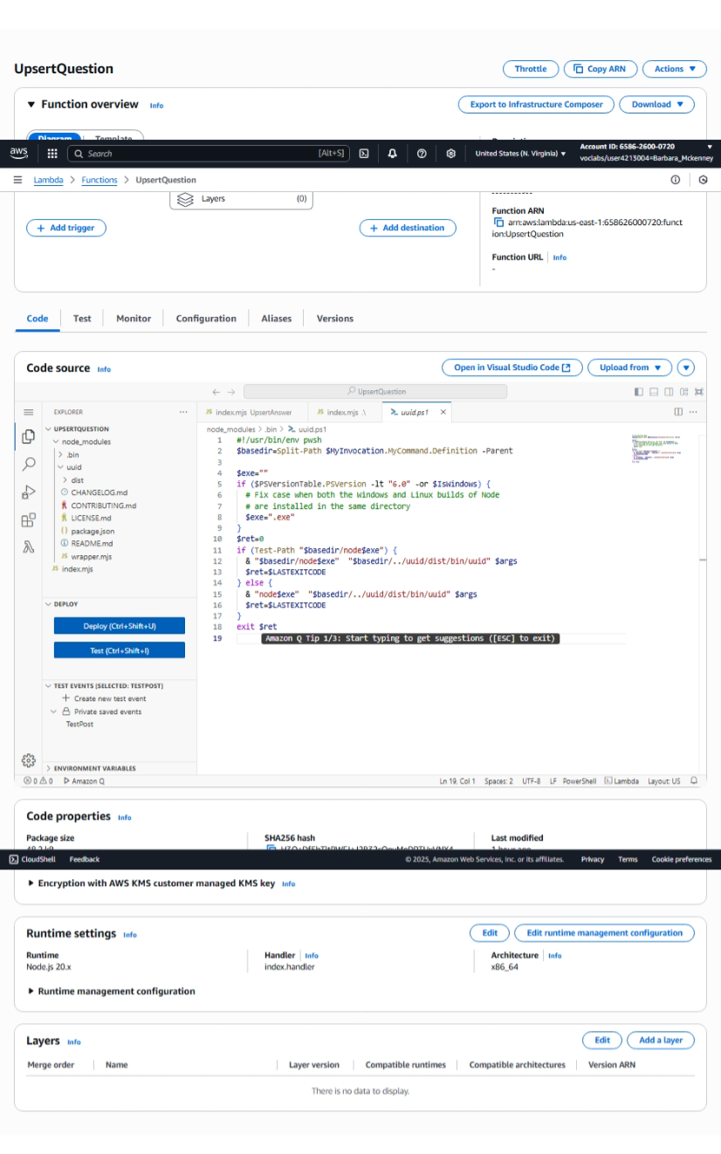

UpsertAnswer – code + directory tree

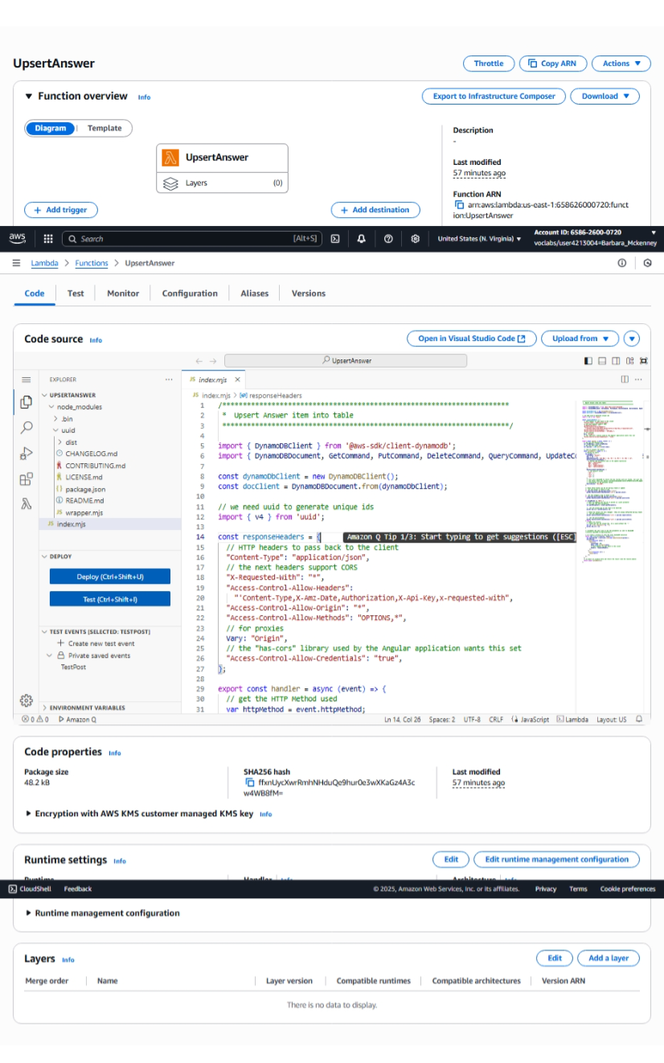

**JSON policy**

